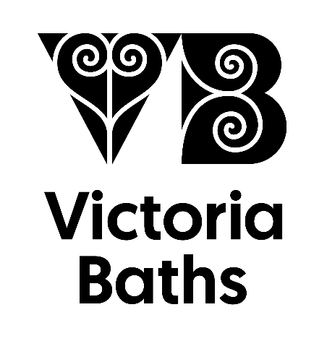
(To be completed by a member of Victoria Baths staff)
Agreed Fee
Payment Status
Visitor Numbers

Confirmed by___________________________
Date_________________

Date of Visit |  | Time of Visit
Group
Contact Person
Address | Post Code
Phone | Home |  | Mobile
Email
Expected Numbers
Type of Tour  Please tick all boxes which apply | £10 per person, minimum charge £100  Gives access to Victoria Baths for up to 3 hours including a short introductory tour
Refreshments: tea/coffee & biscuits
£2.00 per person
Please allow an extra ½ hour
Sandwich Lunch: £6 per person

Please allow an extra 1 hour. A packet of crisps and tea/coffee is included. Please request an order form.
Method of Payment | Please pay on the day with cash, cheque or card. Please make cheques payable to ‘Victoria Baths Trust’.
Any Special Requirements or Instructions? | Please write any extra information such as access requirements or parking

Sandwich Lunch Order
Available to tour groups of 10 or more people.
Price: £6 per person including a freshly made Sandwich, bag of crisps and Tea/Coffee
*All sandwiches are available on freshly baked brown, white or gluten free bread rolls. Please specify bread choice as follows W=White B=Brown GF=Gluten Free
Sandwich Filling | Dietary info | Number required
Ham and cheese
Ham salad
Tuna mayo
Chicken and bacon
Chicken salad
Sausage roll
Cheese | Vegetarian
Cheese & onion | Vegetarian
Egg mayo | Vegetarian
Vegan Hoi Sin | Vegan
Vegan New Yorker | Vegan
Vegan Coronation Cauliflower | Vegan

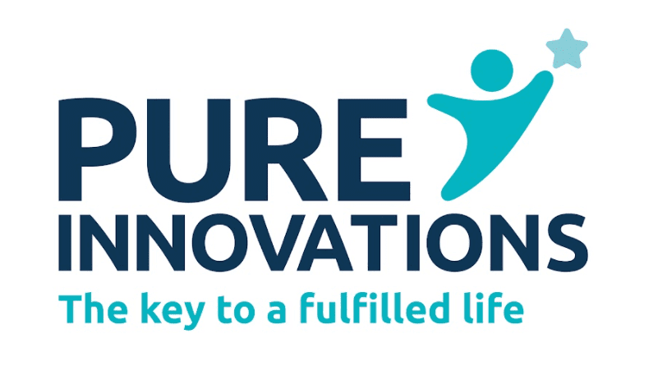
Our sandwiches are provided by Pure Kitchen, a not for profit organisation run by the Charity Pure Innovations, whose key aims are to promote independent lifestyles, supporting people with a disability and disadvantaged groups. Pure Kitchen bakery is located in the heart of Stockport, providing our clients with the training needed to create Bread, Cake, and Buffets from scratch, which is then delivered to our own cafes and external partners throughout Greater Manchester. www.pureinnovations.co.uk

