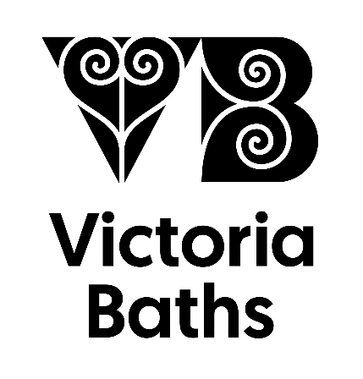
(To be completed by a member of Victoria Baths staff)
Agreed Fee
Payment Status
Visitor Numbers

Confirmed by___________________________
Date_________________

Please note that a booking is not definite until confirmed by a member of Victoria Baths staff.
Date of Visit |  | Time of Visit
Group
Contact Person
Address | Post Code
Phone | Home |  | Mobile
Email
Expected Numbers |  |  | Final Numbers can be confirmed in the week prior to visit
Type of Tour  Please tick all boxes which apply | Tour £8.00 per adult - minimum charge £150.00  Tour of the main areas of building, takes approximately 1 hour, so allow 1½ hours.
Refreshments: tea/coffee & biscuits
£2.00 per person
Please allow an extra ½ hour
Additional off limits tour £4.00 per person

Allow 1 hour extra. This tour goes through areas of the building not usually accessible to visitors.
Sandwich lunch: £6.00 per person

Includes packet of crisps, and tea/coffee.
Please allow 1 hour
Method of Payment | Please write any extra information such as access requirements or parking
Any Special Requirements or Instructions?
Please return by email to: enquiries@victoriabaths.org.uk
Or by post to: Victoria Baths, Hathersage Road, Chorlton-on-Medlock, Manchester, M13 0FE
Sandwich Lunch Order
Available to tour groups of 10 or more people.
Price: £6 per person including a freshly made Sandwich, bag of crisps and Tea/Coffee
*All sandwiches are available on freshly baked brown, white or gluten free bread rolls. Please specify bread choice as follows W=White B=Brown GF=Gluten Free
Sandwich Filling | Dietary info | Number required
Ham and cheese
Ham salad
Tuna mayo
Chicken and bacon
Chicken salad
Sausage roll
Cheese | Vegetarian
Cheese & onion | Vegetarian
Egg mayo | Vegetarian
Vegan Hoi Sin | Vegan
Vegan New Yorker | Vegan
Vegan Coronation Cauliflower | Vegan

Our sandwiches are provided by Pure Kitchen, a not for profit organisation run by the Charity Pure Innovations, whose key aims are to promote independent lifestyles, supporting people with a disability and disadvantaged groups. Pure Kitchen bakery is located in the heart of Stockport, providing our clients with the training needed to create Bread, Cake, and Buffets from scratch, which is then delivered to our own cafes and external partners throughout Greater Manchester. www.pureinnovations.co.uk

